Ovo je zapravo Transformer Fleet Management Dashboard i po funkcionalnosti je između:
- SCADA
- Asset Performance Management (APM)
- Digital Twin
- Predictive Maintenance
Na temelju ove slike napravio bih sljedeću Quasar arhitekturu.
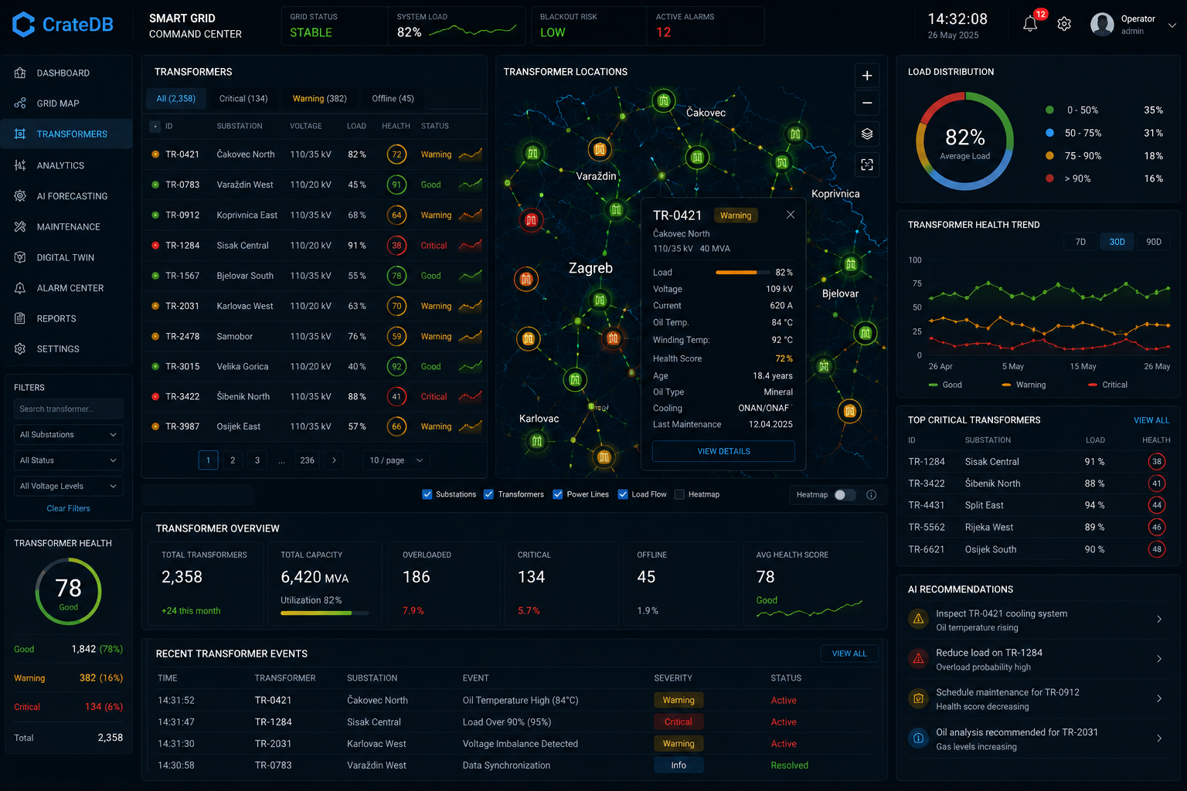

Struktura
src/  ├── pages/  │  │ └── Transformers.vue  │  ├── components/transformers/  │  │ ├── TransformerTable.vue  │ ├── TransformerMap.vue  │ ├── TransformerOverview.vue  │ ├── TransformerHealthCard.vue  │ ├── TransformerHealthTrend.vue  │ ├── TransformerDistribution.vue  │ ├── CriticalTransformers.vue  │ ├── TransformerEvents.vue  │ ├── AIRecommendations.vue  │ ├── TransformerDetailsDialog.vue  │ └── TransformerFilters.vue  │  ├── stores/  │  │ ├── transformerStore.js  │ ├── websocketStore.js  │ └── mapStore.js  │  ├── services/  │  │ ├── api.js  │ ├── websocket.js  │ └── crateQueries.js  │  └── router/ | 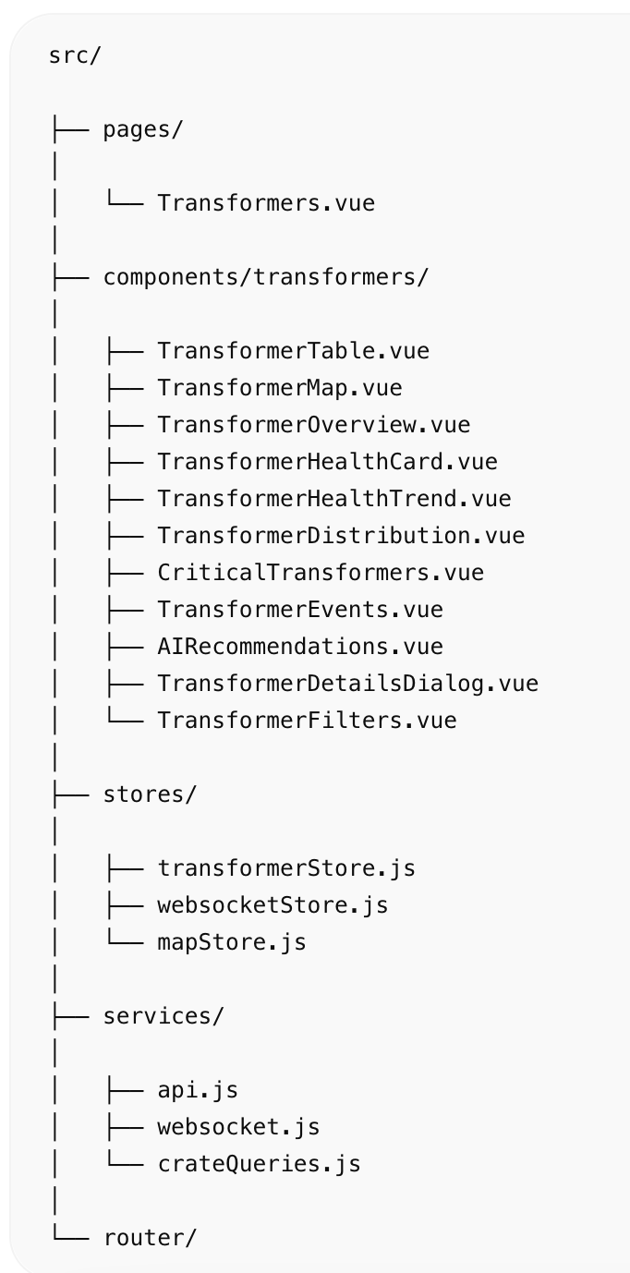

Transformers.vue
<template>  <q-page class="bg-dark text-white q-pa-md">  <div class="row q-col-gutter-md">  <!-- LEFT -->  <div class="col-2">  <TransformerFilters />  <TransformerHealthCard />  </div>  <!-- CENTER -->  <div class="col-7">  <TransformerTable />  <TransformerOverview />  <TransformerEvents />  </div>  <!-- MAP -->  <div class="col-3">  <TransformerMap />  <TransformerDistribution />  <TransformerHealthTrend />  <CriticalTransformers />  <AIRecommendations />  </div>  </div>  </q-page>  </template> | 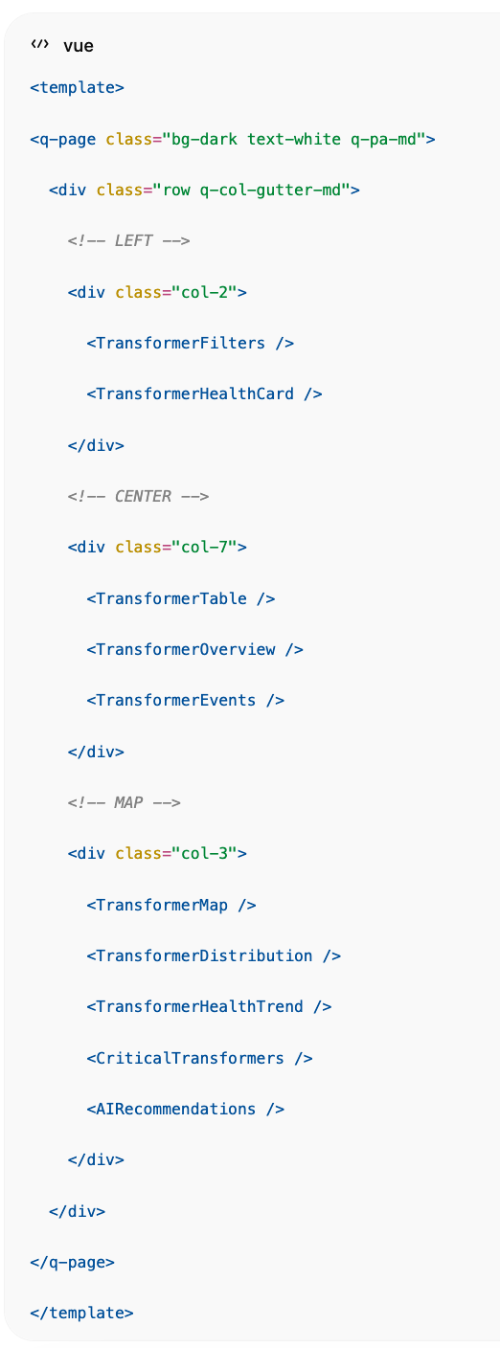

TransformerTable.vue
Glavni fleet pregled.
<template>  <q-card dark bordered class="bg-grey-10">  <q-card-section>  <div class="row justify-between">  <div class="text-h6">  Transformers  </div>  <q-input  dense  dark  outlined  v-model="search"  placeholder="Search..."  />  </div>  </q-card-section>  <q-table  dark  flat  bordered  :rows="rows"  :columns="columns"  row-key="id"  >  <template v-slot:body-cell-health="props">  <q-td>  <q-circular-progress  :value="props.row.health"  size="40px"  show-value  :color="healthColor(props.row.health)"  >  {{ props.row.health }}  </q-circular-progress>  </q-td>  </template>  </q-table>  </q-card>  </template> | 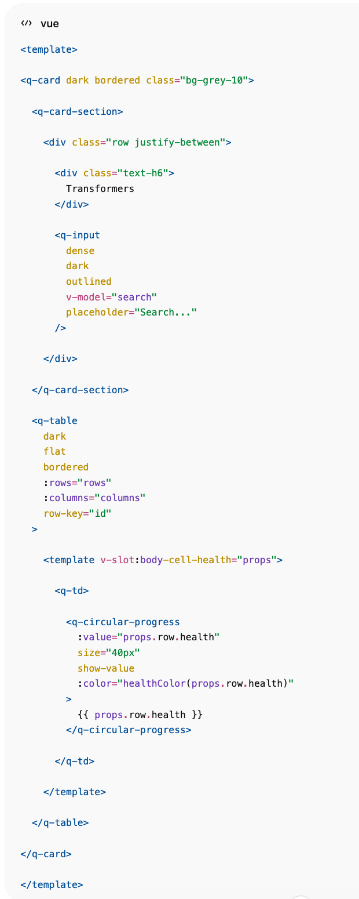

TransformerMap.vue
Map panel iz centra slike.
Za produkciju:
npm install mapbox-gl
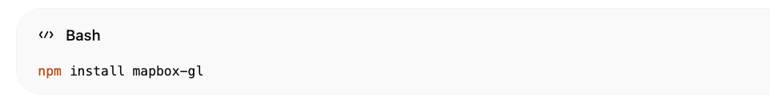
<template>  <q-card dark bordered>  <q-card-section>  Transformer Locations  </q-card-section>  <div id="map"></div>  </q-card>  </template>  <style scoped>  #map{  height:540px;  }  </style> | 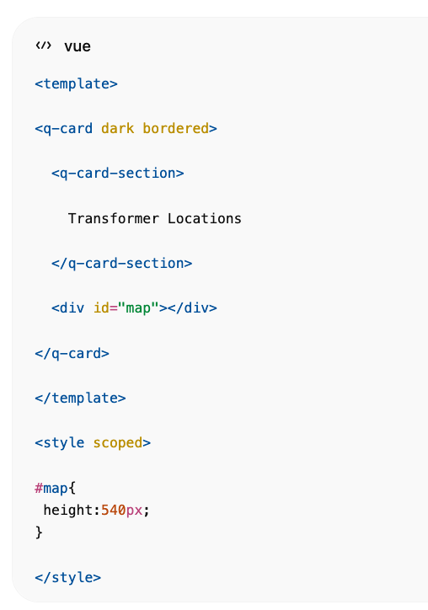

TransformerDetailsDialog.vue
Klik na TR-0421.
<q-dialog v-model="show">  <q-card  dark  style="width:450px"  >  <q-card-section>  <div class="text-h6">  TR-0421  </div>  <q-badge color="orange">  Warning  </q-badge>  </q-card-section>  <q-list>  <q-item>  <q-item-section>  Load  </q-item-section>  <q-item-section side>  82%  </q-item-section>  </q-item>  <q-item>  <q-item-section>  Voltage  </q-item-section>  <q-item-section side>  109 kV  </q-item-section>  </q-item>  <q-item>  <q-item-section>  Oil Temperature  </q-item-section>  <q-item-section side>  84°C  </q-item-section>  </q-item>  <q-item>  <q-item-section>  Health Score  </q-item-section>  <q-item-section side>  72%  </q-item-section>  </q-item>  </q-list>  <q-card-actions>  <q-btn  color="primary"  label="Digital Twin"  />  </q-card-actions>  </q-card>  </q-dialog> | 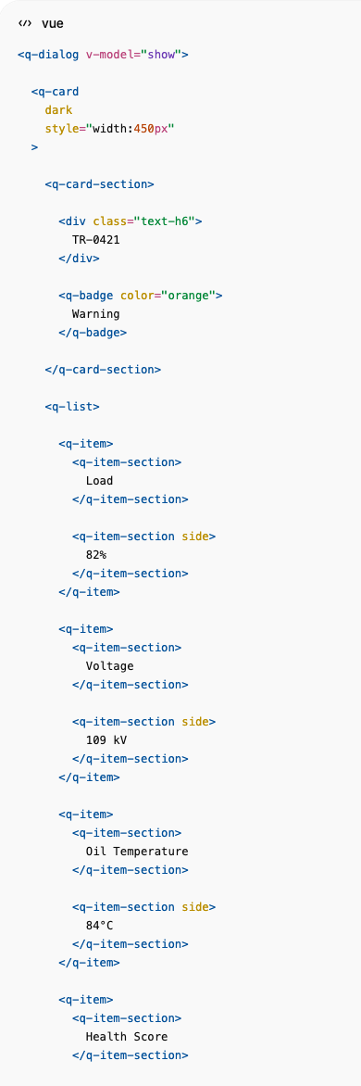  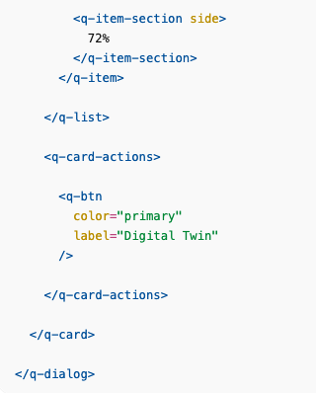

TransformerOverview.vue
Donji KPI panel.
<template>  <div class="row q-col-gutter-md">  <div  class="col"  v-for="item in overview"  :key="item.title"  >  <q-card dark bordered>  <q-card-section>  <div class="text-caption">  {{ item.title }}  </div>  <div class="text-h4">  {{ item.value }}  </div>  </q-card-section>  </q-card>  </div>  </div>  </template>  <script setup>  const overview = [  {  title:'Total Transformers',  value:'2,358'  },  {  title:'Capacity',  value:'6,420 MVA'  },  {  title:'Overloaded',  value:'186'  },  {  title:'Critical',  value:'134'  },  {  title:'Offline',  value:'45'  },  {  title:'Health Score',  value:'78'  }  ]  </script> | 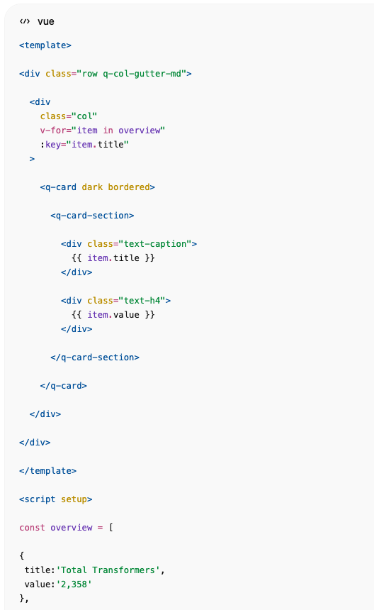  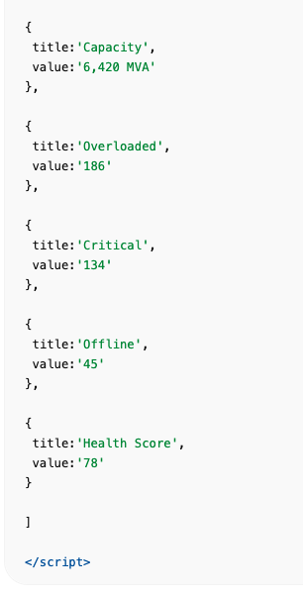

TransformerHealthTrend.vue
ECharts.
npm install echarts vue-echarts
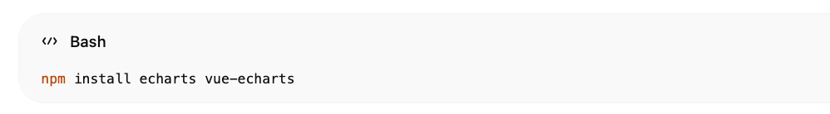
<template>  <q-card dark bordered>  <q-card-section>  Transformer Health Trend  </q-card-section>  <v-chart  :option="option"  style="height:250px"  />  </q-card>  </template> | 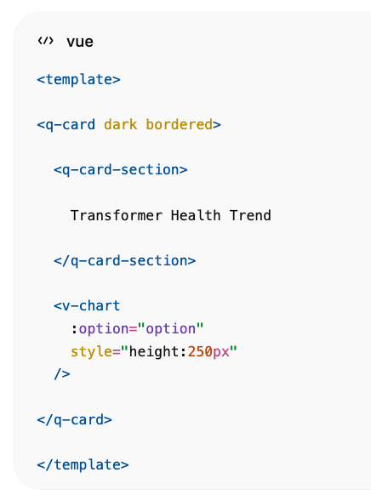
Prikazuje:
- Good
- Warning
- Critical
kao na slici.

CriticalTransformers.vue
<template>  <q-card dark bordered>  <q-card-section>  Top Critical Transformers  </q-card-section>  <q-list separator>  <q-item  v-for="item in transformers"  :key="item.id"  >  <q-item-section>  {{ item.id }}  </q-item-section>  <q-item-section side>  <q-badge color="red">  {{ item.health }}  </q-badge>  </q-item-section>  </q-item>  </q-list>  </q-card>  </template> | 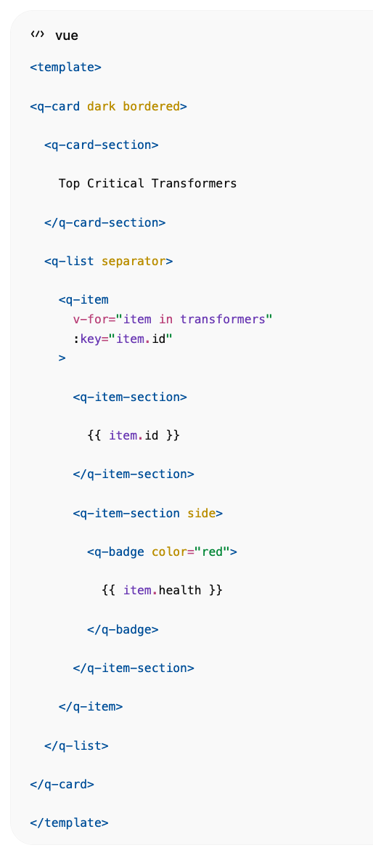

AIRecommendations.vue
<template>  <q-card dark bordered>  <q-card-section>  AI Recommendations  </q-card-section>  <q-list separator>  <q-item  v-for="item in recommendations"  :key="item.title"  >  <q-item-section>  <div>  {{ item.title }}  </div>  <div class="text-grey">  {{ item.description }}  </div>  </q-item-section>  </q-item>  </q-list>  </q-card>  </template> | 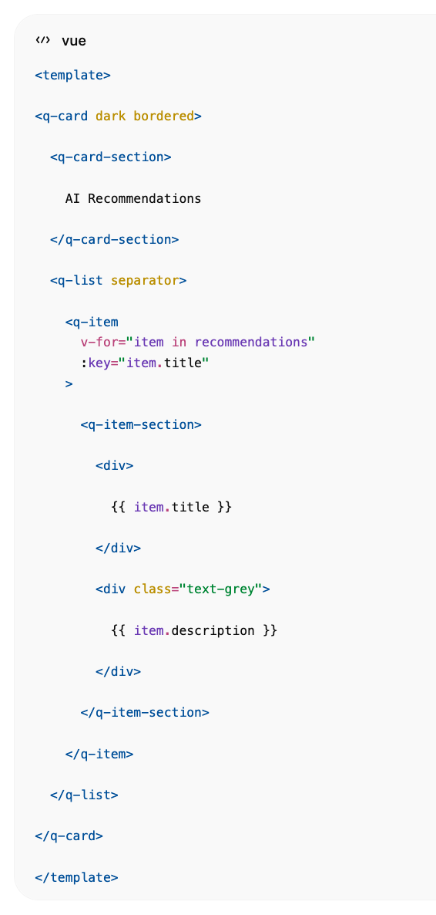

Realtime EMQX Feed
// services/websocket.js  const ws = new WebSocket(  'ws://localhost:8000/ws/transformers'  )  ws.onmessage = (event)=>{  const data = JSON.parse(event.data)  transformerStore.update(data)  } | 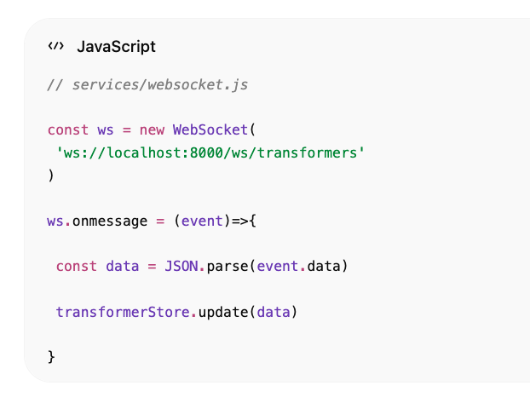

CrateDB upiti

Fleet Health
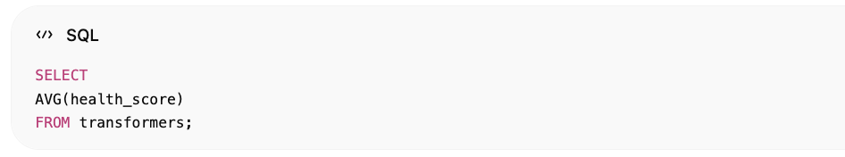
SELECT
AVG(health_score)
FROM transformers;

Warning
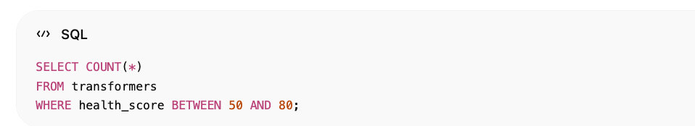
SELECT COUNT(*)
FROM transformers
WHERE health_score BETWEEN 50 AND 80;

Critical
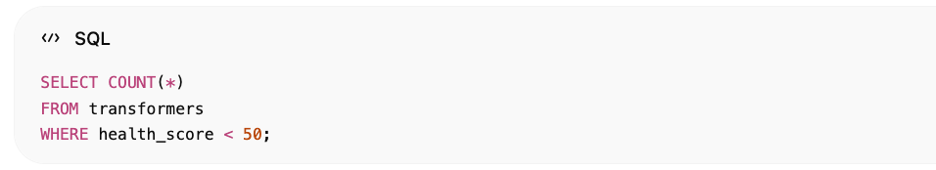
SELECT COUNT(*)
FROM transformers
WHERE health_score < 50;

Map Layer
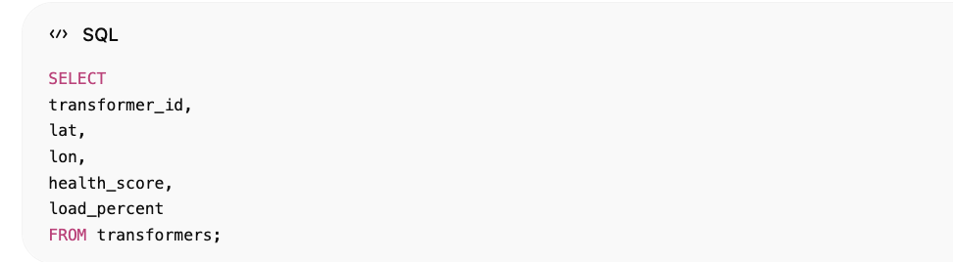
SELECT
transformer_id,
lat,
lon,
health_score,
load_percent
FROM transformers;

Digital Twin integracija
Klik na transformator:
TR-0421
otvara:
/transformers/TR-0421
gdje se otvara:
- 3D transformer model
- svi senzori
- oil analytics
- DGA analytics
- maintenance history
- AI predictions
- RUL prediction
- failure probability
- work orders
- alarm history
Točno kao enterprise utility Asset Performance Management platforma za CrateDB Smart Grid demonstrator.
窗体顶端

窗体底端

